DATE: ____ ______HT: _ _____ WT: __ _____ BP: _____ ____ TEMP: ___

PATIENT HISTORY INFORMATION
PATIENT NAME: __________________________________________________ DOB: ______________ AGE: ___________
REFERRAL DOCTOR: __________________________ PRIMARY CARE PHYSICIAN: _______________________________

Please list pharmacy you would like to have on file:
Please list any medication allergies:
PAIN QUESTIONARE
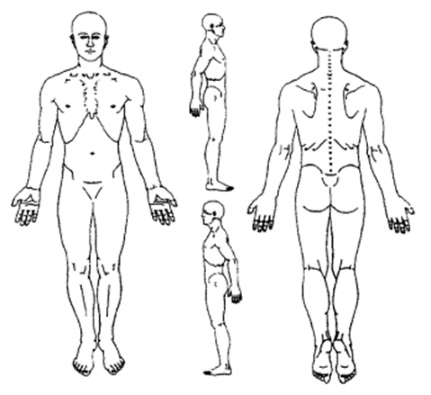
Circle the areas of pain. Mark an “X” in areas of numbness.
When did the pain start? ________________________ ___
Where do you feel the most pain?
mostly back mostly leg R/L both back and leg mostly neck mostly arm R/L neck and arm other___________________
Circle your current pain level:
0 1 2 3 4 5
6 7 8 9 10
At its best: ______ At its worst: ______
Would you describe your pain as:
dull sharp burning shooting electric other________________
Do you have weakness? yes no
If yes, where? __________________
Do you have any of the following sensations in your extremities? numbness tingling burning other______________
Any disturbance of: bowel bladder sexual function
Is current pain related to a previous injury/trauma? _____________________________________________
Do any of the following increase your pain?

Coughing Sneezing Straining Sitting Lifting Twisting Standing Stress Cold Walking Sleeping on stomach/back other__________

How many hours do you sleep in a typical night? ____________________ Does your pain affect your sleep?  yes  no
What other doctors have you seen for this condition? __________________________________________________________
Are you currently working? yes no If no explain________________________________________________________
Is this an active Workers Compensation Case? yes no If yes Carrier: _____________________________________
Have you hired an attorney because of this injury? yes no If yes, who? ____________________________________
Please check the following for pain interferences.
General Activity/Daily Living (bathing, cooking, chores, etc.) Mood Walking ability
Relationships with other people Enjoyment of Life other__________________________________________
Please check any of the following you have tried to control your pain.
Medications Physical/Aquatic Therapy Chiropractor Acupuncture Massage Therapy Hot/Cold Therapy TENS Unit

Circle any of the following problems you are dealing with.
General | Musculoskeletal | Dermatology | HEENT | Respiratory
Change in Appetite | Arthralgia’s (joint pain) | Hives | Blurred Vision | Cough
Fatigue | Crepitus (joint popping) | Infection | Glaucoma R/L | Hemoptysis (Coughing Blood)
Fever/Chills | Deformity | Jaundice | Cataracts R/L | Shortness of Breath
Night Sweats | Muscle Loss | Rash | Dry Mouth
Weight Gain | Stiffness |  | Headache
Weight Loss |  |  | Vertigo
 |  |  | Deafness
Cardiology | Gastroenterology | Genitourinary | Neurology | Endocrinology
Chest Pain | Abdominal Pain | Change in Urinary Habit | Dizziness | Diabetes
Edema (Swelling) | Change in Bowel Habits | Increased Frequency | Numbness | Thyroid Problems
Palpitations | Constipation | Hematuria | Seizures
 | Diarrhea | Incontinence | Tingling | Psychology
 | Fecal Incontinence | UTI | Weakness | Anxiety
 | Nausea |  | History of Stroke | Depression
 | Vomiting |  |  | Suicidal Ideation

Please mark an (X) for any of the following medical conditions you have.
Medical History | Yes | No | Medical History | Yes | No
Hypo/Hyper Thyroidism |  |  | Diabetes Type 1/2
HIV/AIDS |  |  | High Cholesterol
Carpal Tunnel Syndrome |  |  | High Lipids
Migraines |  |  | Hypertension
Coronary Artery Disease |  |  | Bleeding Problems
Cancer |  |  | Rheumatologic Disorders
COPD |  |  | Asthma
GERD |  |  | Heart Attack
Peripheral Vascular Disease |  |  | Blood Clots
Sleep Apnea |  |  | GI Ulcers
Osteoarthritis/Osteoporosis |  |  | Kidney Problems
Other: |  |  | Liver Problems (Hepatitis)

Abdominal Surgery | Hernia Repair: Umbilical/Inguinal | Cesarean Section (C-Section)
Tonsillectomy/Adenoidectomy | Hip Replacement R/L | Knee Surgery
Amputation: ______________ | Hysterectomy | Radiofrequency Ablation
Appendectomy | Knee Replacement R/L | Spinal Cord Stimulator
Arthroscopy | Kidney Surgery | Pain Pump
Back Surgery | Neck Surgery | Shoulder Surgery
Carpal Tunnel Release | Cholecystectomy | Pacemaker
Colon Surgery | Thyroidectomy | Gastric Bypass Surgery
Transplant | Other:
Please circle past surgeries:

Do you drink Alcohol? | Do you Smoke? | Do you use Illicit drugs? | Marital Status | Activities and Hobbies | Disability?
yes no  How much? _______ | yes no  How long? _______  How much? _______ | yes no  Marijuana, cocaine, other_____________ | Single Married  Other:________ | List:____________________________________ | yes  no
Please mark an (X) for any of the following:

Please mark an (X) for any of the
Family History | Mother | Father
Cancer
Type:
Heart Disease
Back / Neck pain
Diabetes
Migraines
High Blood Pressure
Rheumatoid Arthritis
Neurologic Disorder
Type:
Other
following family medical history:
Are you allergic to x-ray or contrast dye? yes no Explain:________________________________________________
List all medications along with prescribing doctor and dose (including blood thinners):
What are your expectations/goals in being treated with Pain Management?

